*Setup of the UNCL:*

The UNCL electronics (shift register) should be connected to a computer and printer. The INCC software includes a routine for “Collar” measurements. The computer code will be used to collect the data and provide a printout of the results. Setting up the INCC software is complex and we will go through the steps below.

1. *Detector Setup*

Create a new detector “UNCLant” with “Maintain | Detector | Add/Delete…”

The detector parameter values are shown below:

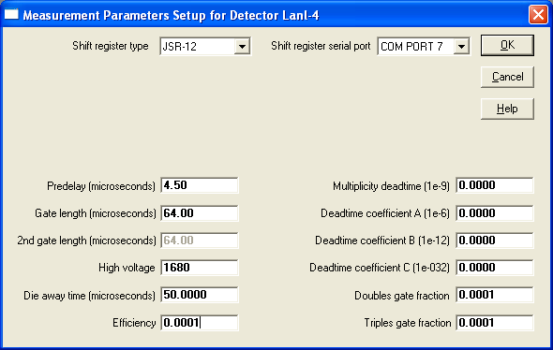

May be different!

After the detector is defined, use “Setup | Facility/Inspection…” to choose this detector

1. *Material Type*

Create a new material type “BWR” under “Maintain | Material Type Add/Delete…”

Choose “Maintain | Calibration | Analysis Methods” and select “Collar” as the analysis type as shown in the figure below.

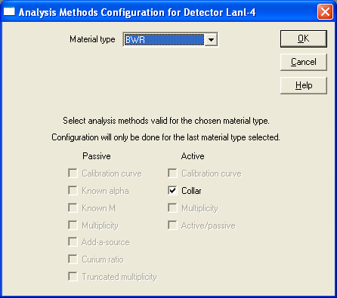

Now set up the calibration parameters from LA-11965-MS. Remember to choose all of the values for the case of BWR No Cd. (The report gives values for PWR Cd, PWR No Cd, BWR Cd and BWR No Cd).

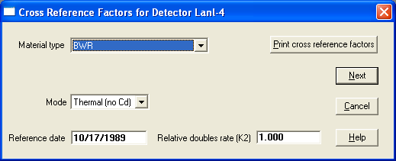Select “Maintain | Calibration | Collar…” and begin entering the calibration information into the INCC software. There will be several menus to go through, with the first menu shown below:

Your instructor will provide the reference date and k2 parameter for the collar.

Note: INCC has a very useful “help” feature. Press F1 with the cursor in any field to see a text box with further information.

Press next and set up the values in the following screen:

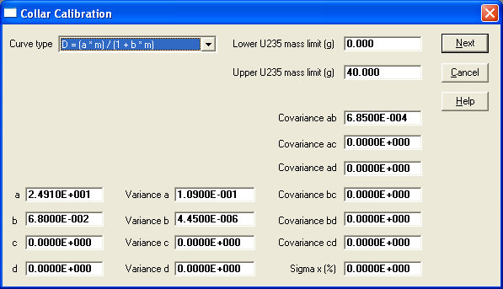

This is the universal BWR No Cd calibration.

Press next to enter the values for the poison correction and the heavy metal correction.

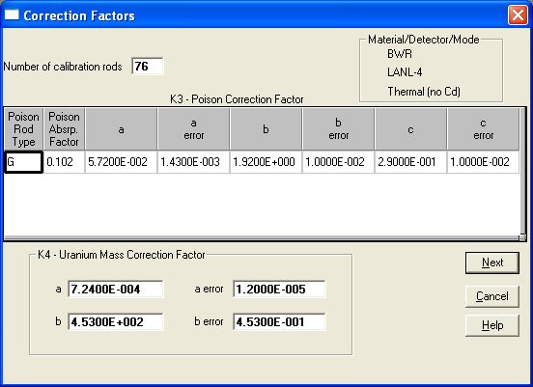

For the k3 factor, these are the standard parameters for Gd poison rod corrections. Remember that the correction for thermal mode (No Cd) is much larger than for fast mode.

For the k4 factor these are the standard parameters (press F1 for each of the boxes).

Press next to see the values for the k5 factor. Our dummy BWR assembly has 4 steel rods at the four corners to hold the pins together. These are not a normal part of a BWR assembly. A k5 factor of 1.03 should be entered to make this correction. Your instructor will provide an additional k5 factor for the 252Cf interrogation source.

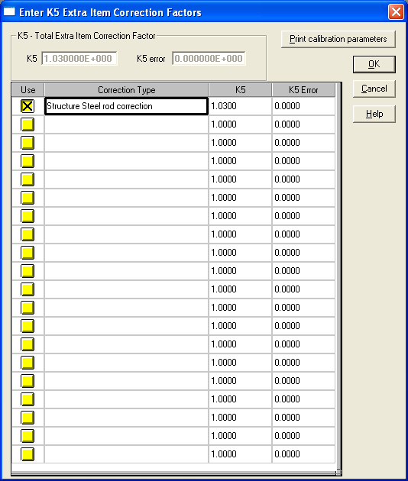 Press OK to complete the calibration procedure.

1. *Interrogation Source Strength*

The relative source strength of the interrogation source that you choose has to be entered in the normalization setup.

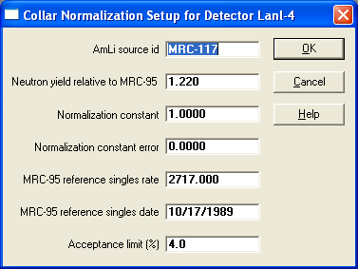Choose Maintain / Normalization Setup. Select “Collar normalization test”. The following screen shows the setup for MRC-117. The relative yield will have to be changed if you use another interrogation source. Press F1 when the cursor is in the neutron yield box to find where to obtain the relative values.

The INCC program is now setup ready to go.

*Verification Procedure for BWR Fuel:*

With the collar empty and no interrogation source present, measure the passive background for 10 cycles of 20 seconds. The coincidence rate should be statistically zero.

Place the collar around the fuel assembly. Select “Acquire | Verification” and enter the details of the assembly. The verification measurement menu will appear as shown below:

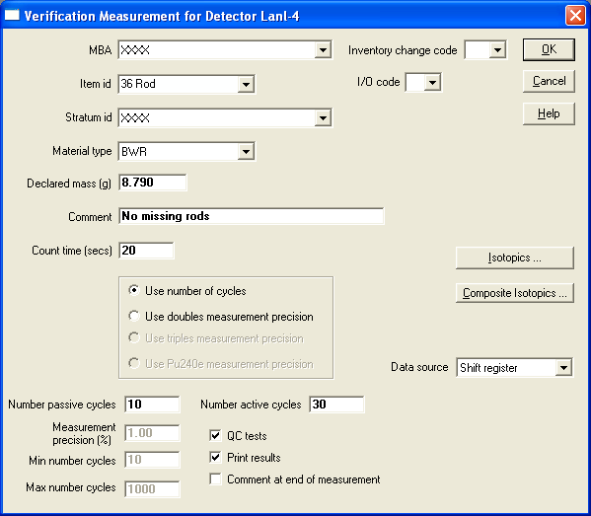

When you press OK, the next menu allows you to enter more information about the collar. Note that the calibration was made using 235U mass per cm. (We leave the active length at the fictitious value of 1 cm):

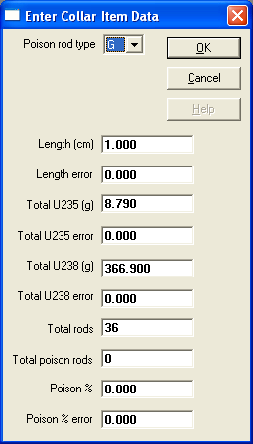

The 238U value is the declared value for 36 rods. Press OK to confirm the k5 correction factor and then OK to reach the main data acquisition control screen.

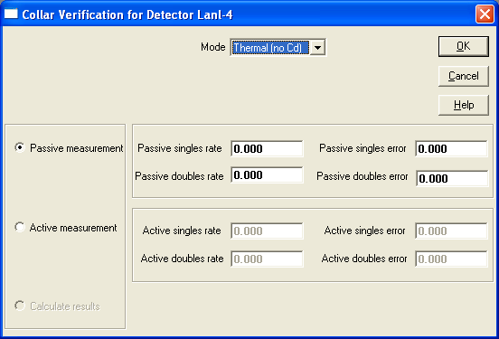

Under normal conditions you will select passive measurement and then OK. INCC will then start to collect the passive data. When it is finished, INCC will fill in the passive data fields. AFTER the instructor has put the 252Cf source in the collar, select Active Measurement radio button and press OK. INCC will then take the active data. When it has finished you will be able to select Calculate results radio button to get the measured values.

The printout will contain the net passive Doubles rate (from 238U) and the net active Doubles rate (from induced fission in 235U caused by 252Cf neutrons. The printout will also show the Net Corrected Doubles rate after all the correction factors are applied. This corrected Doubles rate is used to calculate the 235U g/cm from the calibration curve. Your result should be within 3 standard deviations of the declared value. Fill in the answers in the table below.

*Sensitivity Measurements of the UNCL:*

Now ask the instructor to remove 2 rods from the assembly and replace them with stainless steel cladded lead dummy rods. For each case, fill in the position of the removed rods in the graphics below (the star shows the position of the 252Cf source). Repeat the measurement procedure as above without changing the declaration. See how the position of the removed rods changes the operator-inspector difference. Before you carry out the measurement, choose the position will change the answer the *least*.

|  |  |  |  |  |
| --- | --- | --- | --- | --- |
| Case | Corrected Doubles | Measured Mass g/cm | Operator Inspector Difference  (O-I) % | Uncertainty on O-I % |
| 36 rods | 64.466+-7186 | 3.023+-0.00513 | 65.606 | 0.5835 |